LD8 DC Commissioning Guide

|  |  |
| --- | --- |
| Author | Anthony Xing |
| Date | 08-03-2018 |
| Version | 1.0 |
| Verify | Sven Huster |

Version History Table

|  |  |  |  |
| --- | --- | --- | --- |
| Version | Date | Author | Update |
| 1.0 | 08-03-2018 | Anthony Xing | Initial |

Table of Content

[1 Project Introduction 4](#_Toc508704746)

[1.1 Important Information 4](#_Toc508704747)

[1.2 Target Setting 4](#_Toc508704748)

[1.3 Hardware & Software 5](#_Toc508704749)

[1.4 License Information 5](#_Toc508704750)

[1.5 Optional Record 6](#_Toc508704751)

[2 Preparation 7](#_Toc508704752)

[2.1 Travel Plan 7](#_Toc508704753)

[2.2 Getting Software 7](#_Toc508704754)

[2.3 ReFERENCE Documents 7](#_Toc508704755)

[2.4 2.4 Material Check-list 7](#_Toc508704756)

[2.5 Current Setting Description 8](#_Toc508704757)

[3 3 Risk Evaluation 8](#_Toc508704758)

[3.1 3.1 Risks 8](#_Toc508704759)

[3.2 3.2 Rollback Solution 8](#_Toc508704760)

[4 Operation 8](#_Toc508704761)

[4.1 4.1 Physical Connection 8](#_Toc508704762)

[4.2 4.2 Server OS Installation 8](#_Toc508704763)

[4.3 4.3 Network Configuratione 8](#_Toc508704764)

[5 Verify 9](#_Toc508704765)

[5.1 Server OS 9](#_Toc508704766)

[5.2 Network 9](#_Toc508704767)

# Project Introduction

## Important Information

1. Operator - Anthony Xing
2. Time Schedule: 26-03-2018
3. Link Diagram

3.1 Both hs01 & hs02 have 2 optical port (10GE) link to ar01 & ar02, and 2 electric port (GE) link to ar01 & ar02

3.2 Optical link for business traffic and electric link for management.

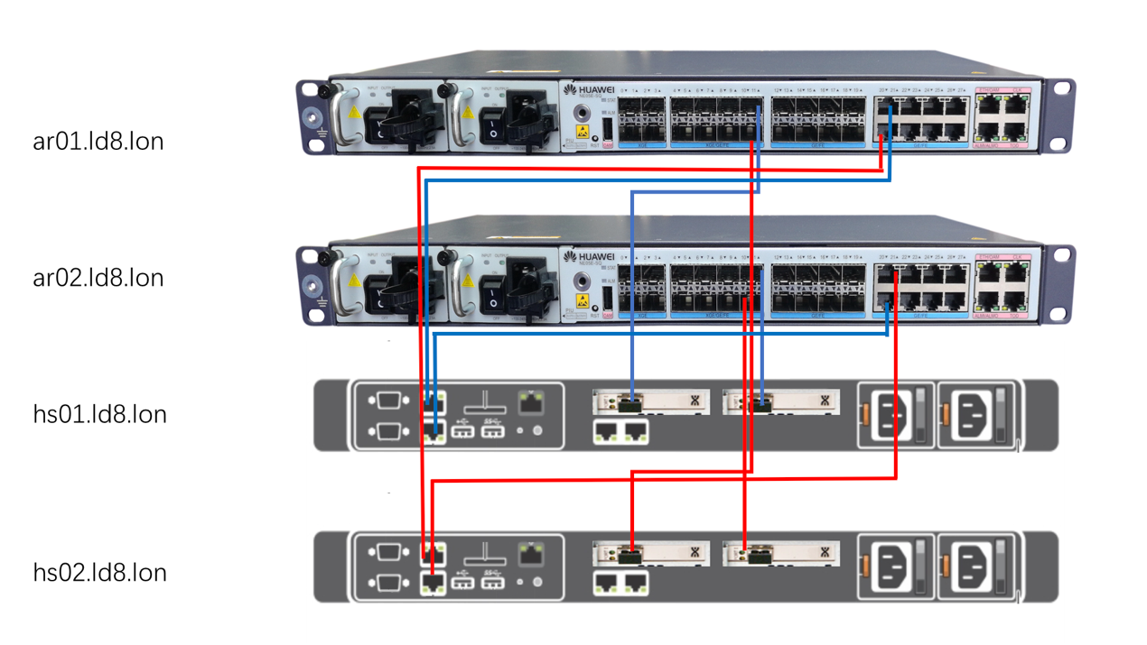

1. IP Address allocation:



## Target Setting

* + 1. Finish additional CPU&Fan installation for hs01
    2. Physical link between 2 servers and 2 routers
    3. Ubuntu OS installation for 2 servers
    4. Directly ping between 2 servers and 2 routers
    5. Remote management verify for 2 servers

## Hardware & Software

|  |  |  |  |  |
| --- | --- | --- | --- | --- |
|  | **Device** | **Software** | **Target** | **Memo** |
| **Tasks** | Hs01.ld8. lon  Dell Poweredge430 | N/A | Ubuntu 16.04.4 Server | Install OS |
| Hs01.ld8.lon  Dell Poweredge430 | N/A | Additional CPU&Fan | Add hardware and verify |
| Hs01.ld8.lon  Dell Poweredge430 | N/A | Connect with ar01&ar02 | Physical connect and configure IP address |
| Hs02.ld8.lon  Dell Poweredge430 | N/A | Ubuntu 16.04.4 Server | Install OS |
|  | Hs01.ld8.lon  Dell Poweredge430 | N/A | Connect with ar01&ar02 | Physical connect and configure IP address |
|  | Ar01.ld8.lon | V300R002C10SPC200 | Connect with hs01&hs02 | Physical connect and configure IP address |
|  | Ar02.ld8.lon | V300R002C10SPC200 | Connect with hs01&hs02 | Physical connect and configure IP address |

## License Information

iDRAC8 Enterprise

DE00000215078681

1

iDRAC8 Enterprise

DE00000215078678

1

iDRAC8 Enterprise

DE00000215078679

1

iDRAC8 Enterprise

DE00000215078680

1

## Optional Record

#### recode service of servers:

HS01: HS02:

Register warranty online

#### idrac8 + Ubuntu installation

#### physical connection between:

1. HS01.LD8.LON TO AR01-LD8.LON Optical

Port To

1. HS01.LD8.LON TO AR02-LD8.LON Optical

Port To

1. HS01.LD8.LON TO AR01-LD8.LON Electric

Port To

1. HS01.LD8.LON TO AR02-LD8.LON Electric

Port To

1. HS02.LD8.LON TO AR01-LD8.LON Optical

Port To

1. HS02.LD8.LON TO AR02-LD8.LON Optical

Port To

1. HS02.LD8.LON TO AR01-LD8.LON Electric

Port To

1. HS02.LD8.LON TO AR02-LD8.LON Electric

Port To

#### Configure ip address on ports

Directly ping OK

#### verify Remote access of hs01.ld8.lon & hs02.ld8.lon

Remote access Hs01.ld8.lon

Remote access Hs02.ld8.lon

# Preparation

## Travel Plan

From Paddington to LD8

6-7 Harbour Exchange Square, Isle of Dogs, London E14 9GE

<https://portal.equinix.com/> Submit on-site visit application in advance

Bring photo ID

## Getting Software

1 Ubuntu16.0.4-Server Done

## ReFERENCE Documents

/Users/anthony/Documents/AX新建站点/poweredge-r430_owner's manual_en-us.pdf /Users/anthony/Documents/AX新建站点/idrac7-8-with-lc-v2.20.20.20_user's guide_zh-cn.pdf



idrac7-8-with-lc-v2.20.20.20\_user's guide\_zh-cn

poweredge-r430\_owner's manual\_en-us

poweredge-r430\_setup guide\_zh-cn

## 2.4 Material Check-list

Laptop OK

Console Cable + Convertor(For NE05E) OK

CPU&fan – Get from Feka Samakuva

Cat5 cable \*4 – Provide by Feka Samakuva

10G optical module \*4 – Ordered by Sven Huster

License of Dell PowerEdge430 OK

Ubuntu - ubuntu-16.04.4-server ISO OK

Ref Document： poweredge-r430\_owner's manual\_en-us OK

## Current Setting Description

Configure IP address on router port  
Enable isis on router port  
Apply ACL on router port (if need)

# Risk Evaluation

## 3.1 Risks

## 3.2 Rollback Solution

N/A

# Operation

## 4.1 Physical Connection

## 4.2 Server OS Installation

## 4.3 Network Configuratione

**Record each operation steps when on site.**

# Verify

## Server OS

* + 1. Check OS version
    2. Check service running

## Network

* + 1. Ping Test
    2. Remote Access